Practical no: 2

Aim: Testing Hypothesis Implement and demonstrate the find-s algorithm for finding the most specific hypothesis based on given set of training data samples. Read the training data from a. CSV file and generate the final specific hypothesis
Description:
Introduction
In Machine Learning, a hypothesis represents the knowledge learned from training data. The Find-S algorithm (Find the Most Specific hypothesis) is one of the simplest algorithms used for concept learning. It learns a hypothesis that is consistent with all positive examples in a dataset.
🔹 Objective
The objective of this experiment is to implement and demonstrate the Find-S algorithm to find the most specific hypothesis from a given set of training data samples. The training data is provided in a CSV file, and the final output will be the hypothesis that describes the target concept.
🔹 Working of Find-S Algorithm
Initialize the hypothesis with the first positive training example.
For each subsequent positive example:
Compare every attribute of the example with the current hypothesis.
If they match → keep it as it is.
If they differ → replace it with a "?" (meaning "any value").
Ignore negative examples (they are not used in Find-S).
The process continues until all training samples are checked.
The final hypothesis is the most specific generalization that covers all positive samples.
Here, the target attribute is EnjoySport.
“Yes” = Positive Example
“No” = Negative Example
🔹 Step-by-Step Hypothesis Evolution
Initial Hypothesis (from first positive sample):
['Sunny', 'Warm', 'Normal', 'Strong', 'Warm', 'Same']
After 2nd positive sample:
['Sunny', 'Warm', '?', 'Strong', 'Warm', 'Same']
After 3rd positive sample (ignored since target = No).
After 4th positive sample:
['Sunny', 'Warm', '?', 'Strong', '?', '?']
✅ Final Most Specific Hypothesis =
['Sunny', 'Warm', '?', 'Strong', '?', '?']
Code:
import pandas as pd
import matplotlib.pyplot as plt

class FindSVisualizer:
def __init__(self, data_file: str, target_column: str = "EnjoySport"):
self.data_file = data_file
self.target_column = target_column
self.data = pd.read_csv(data_file)
self.hypothesis_evolution = []

def train(self):
positive_data = self.data[self.data[self.target_column].str.lower() == "yes"]
if positive_data.empty:
raise ValueError("No positive examples in dataset!")

# Initialize with first positive example
hypothesis = positive_data.iloc[0, :-1].tolist()
self.hypothesis_evolution.append(hypothesis.copy())

# Update hypothesis with each positive sample
for _, row in positive_data.iterrows():
for i in range(len(hypothesis)):
if hypothesis[i] != row[i]:
hypothesis[i] = "?"
self.hypothesis_evolution.append(hypothesis.copy())

return hypothesis

def visualize(self):
attributes = list(self.data.columns[:-1])

fig, ax = plt.subplots(figsize=(10, len(self.hypothesis_evolution)))

# Convert evolution into table rows
table_data = []
for step, hypo in enumerate(self.hypothesis_evolution):
table_data.append([f"Step {step}"] + hypo)

# Create table
column_labels = ["Step"] + attributes
ax.axis("off")
table = ax.table(cellText=table_data,
colLabels=column_labels,
loc="center",
cellLoc="center")

table.auto_set_font_size(False)
table.set_fontsize(10)
table.scale(1.2, 1.2)

plt.title("Find-S Algorithm Hypothesis Evolution", fontsize=14, pad=20)
plt.show()

if __name__ == "__main__":
file_path = "trainings_data.csv" # dataset file
finds = FindSVisualizer(file_path)

final_h = finds.train()
finds.visualize()

print("✅ Final Most Specific Hypothesis:", final_h)
Output:
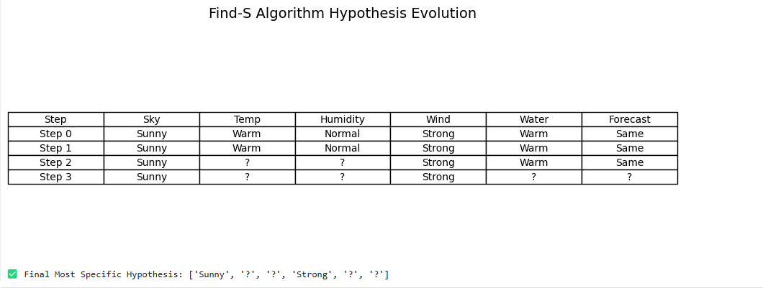

Learnings:
From this experiment, I learned how the Find-S algorithm works by starting with the most specific hypothesis and gradually generalizing it using positive training examples. I understood how to process data from a CSV file, update the hypothesis step by step, and finally obtain the most specific generalization that represents the target concept.

